THE CARNOPHAGE 225 points (+ biomorphs)
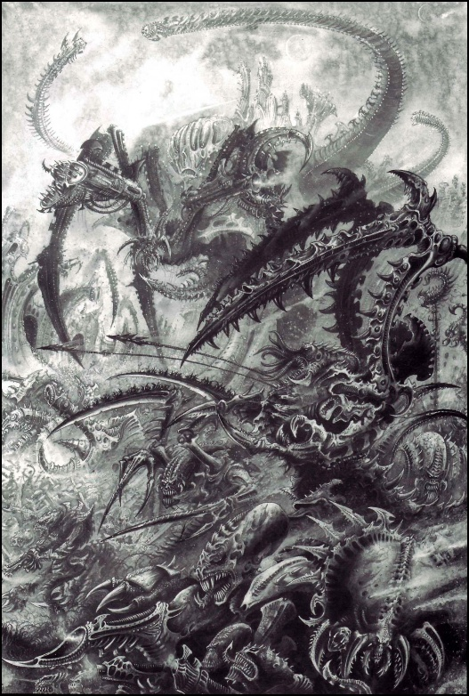
The Carnophage may be included in any Tyranid army by paying the points from the Support section of your points allowance.
Troop Type | M | WS | BS | S | T | W | I | A | Ld
Name | 6 | 5 | 5 | 6 | 8 | 10 | 6 | 3 | 10

WEAPONS Twin Venom Cannons, crushing mandibles, claws and stinging tail
ARMOR Chitinous carapace (3+ save on 2D6).
BIOMORPHS The Carnophage may have up to two biomorphs.
SPECIAL The Carnophage causes terror

The Carnophage is a monstrous, insect-like aberration that is suspected to be a new Tyranid species that has been sighted on the planet Uluru, the latest planet to be set upon by splinters of Hive Fleet Behemoth.
According to sightings by Imperial forces, the beast differs from many of the other larger species of Tyranid and has more physically in common with the smaller Termagants. That is: it relies on it’s middle and back legs for transportation and only it’s front appendages for combat. However, these appendages are each home to a venom cannon.
In combat, the Carnophage will rush forward, spraying corrosive acid crystals that will dissolve even the thickest ceramite, allowing the beast to burrow through whatever, or whoever stands in it’s way.
SPECIAL RULES
Psychology: The Carnophage is immune to all psychological factors. It cannot be affected by fear, terror, or any of the psychological factors described in the Warhammer 40,000 rulebook.
Terror: The Carnophage is a huge, armoured killing machine that liquefies enemies with it highly corrosive venom cannons. It causes terror
Chitinous Body. The Carnophage is covered in thick, overlapping layers of chitinous armour which provide it a saving throw of 3+ on 2D6
Twin Venom Cannons. The two venom cannons on this creature are fired in unison and follow the twin-linked rules. That is, roll to hit once and then resolve two venom cannon templates upon a hit. Both hits will resolve from the same starting point. On a miss, the same is true – resolve the two separate venom cannon templates from the same starting point.

